10.53: a) 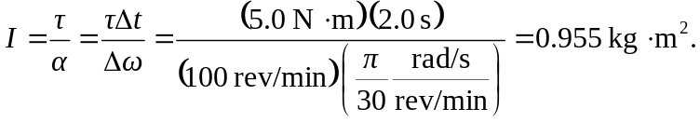
b) Rather than use the result of part (a), the magnitude of the torque is proportional to and hence inversely proportional to 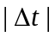; equivalently, the magnitude of the change in angular momentum is the same and so the magnitude of the torque is again proportional to 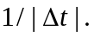 Either way, 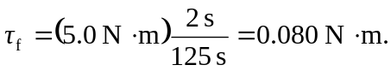
c)

